
Company
Logotype

Cone Beam Computed Tomography- Report



Porur Dental X-rays & CBCT

Patient Name : Mrs. Jayalakshmi | Date of Report : 24.03.2024
Age/ Gender : 52 years/ Female | Region of Interest : CBCT Mandible
Referring doctor: Dr. Balamurali Sai | Indication : Implant assessment
Clinical Notes: Nil
PATIENT INFORMATION

CBCT- Mandible provided
CBCT – IMAGE DETAILS

RADIOGRAPHIC INTERPRETATION

- Completely edentulous mandibular alveolar ridge.
- The mandibular alveolar ridge is present with patchy areas of reduced bone density, bone loss and loss of trabecular pattern in relation to 34, 35, 36, 43, 44, 45 regions.

IMPLANT ASSESSMENT

*In 31 region, the distance between the alveolar ridge and the Lingual artery canal: 19 mm

 | 31 region* | 32 region | 33 region | 34 region
Sub-Crestal (in mm) | 4.71 | 5.78 | 9.03 | 11.42
Mid- Crestal (in mm) | 6.37 | 6.12 | 9.62 | 10.92
Distance between alveolar ridge and the inferior border of mandible (in mm) | 23.43 | 21.12 | 18.51 | 12.45
 | 41 region | 42 region | 43 region | 44 region
Sub-Crestal (in mm) | 5.57 | 7.58 | 10.12 | 12.02
Mid- Crestal (in mm) | 6.89 | 7.78 | 10.35 | 11.64
Distance between alveolar ridge and the inferior border of mandible (in mm) | 21.96 | 20.28 | 12.02 | 15.76

 | 35 region | 36 region | 37 region
Sub-Crestal (in mm) | 8.01 | 7.57 | 7.27
Mid- Crestal (in mm) | 11.75 | 9.65 | 8.81
Distance between alveolar ridge and the inferior alveolar nerve canal (in mm) | 10.16 | 13.52 | 11.56
Distance between alveolar ridge and the inferior border of mandible (in mm) | 20.94 | 23.73 | 24.25

 | 45 region | 46 region | 47 region
Sub-Crestal (in mm) | 7.22 | 8.3 | 6.9
Mid- Crestal (in mm) | 9.08 | 12.28 | 8.54
Distance between alveolar ridge and the inferior alveolar nerve canal (in mm) | 13.67 | 14.37 | 14.36
Distance between alveolar ridge and the inferior border of mandible (in mm) | 25.21 | 24.17 | 23.82

RADIOGRAPHIC IMPRESSION

- Completely edentulous mandibular alveolar ridge.

Kindly correlate with clinical findings


IMAGES FOR REFERENCE

RECONSTRUCTED PANORAMIC VIEW

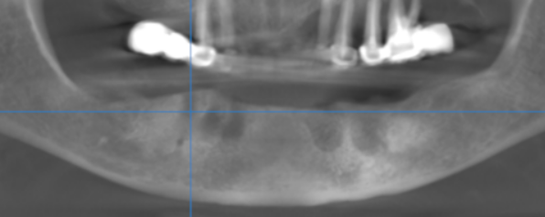

3-DIMENSIONAL VIEW

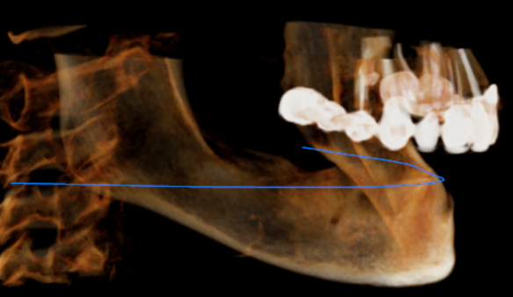
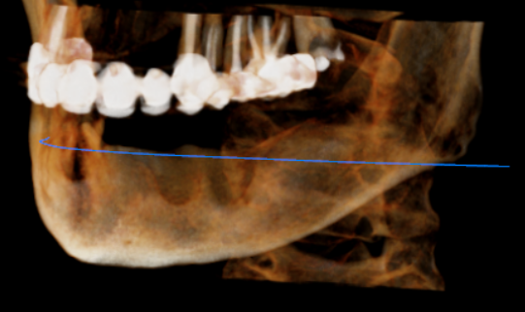

CROSS SECTIONAL VIEW

31 region | 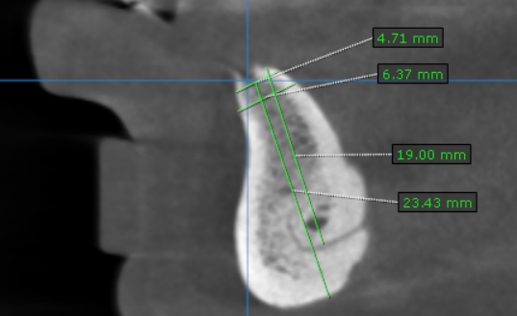
32 region | 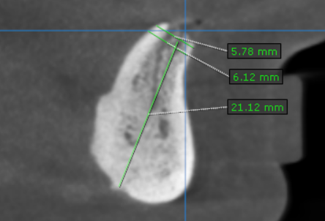
33 region | 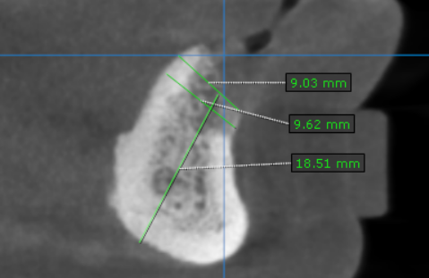
34 region | 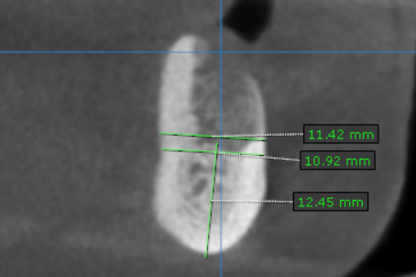
35 region | 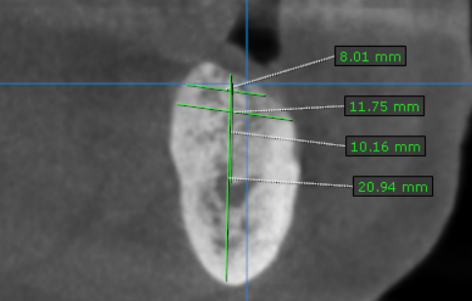
36 region | 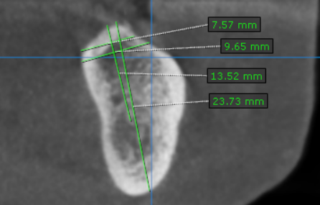
37 region | 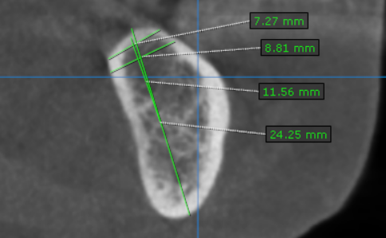
41 region | 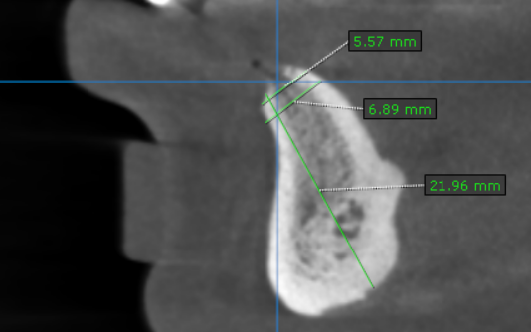
42 region | 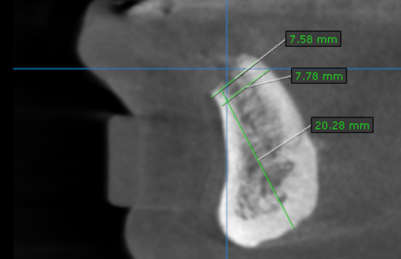
43 region | 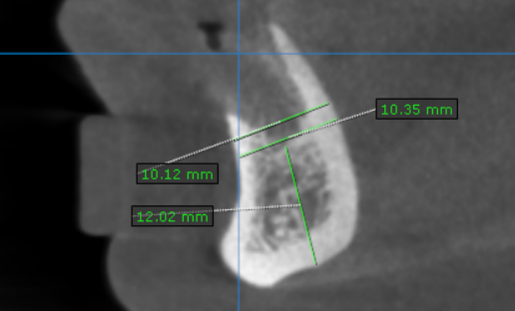
44 region | 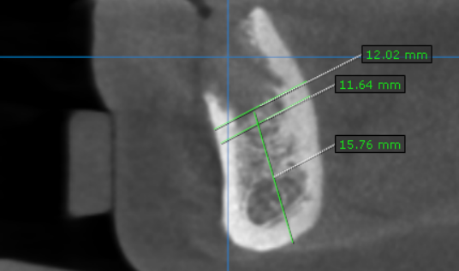
45 region | 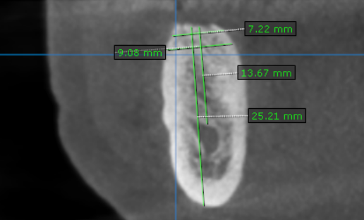
46 region | 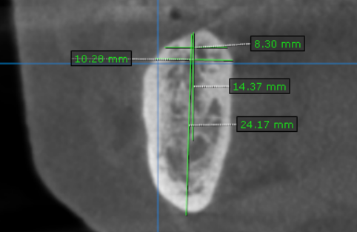 q
47 region | 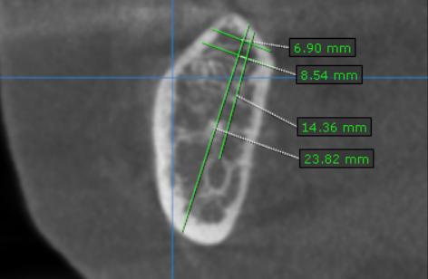

**** End of report ****

